Understanding Dental X-rays OPG & Lateral Cephalogram at Crystal Radiology. (02) 8315 8292

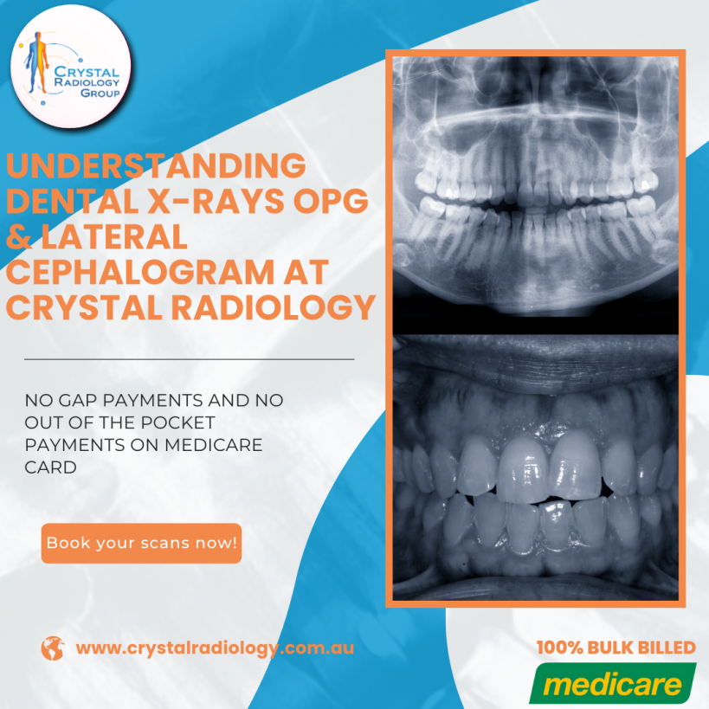

At Crystal Radiology, we understand that accurate and detailed imaging is essential for diagnosing and treating a wide range of dental and maxillofacial issues. Our clinic offers a comprehensive array of dental imaging services designed to provide practitioners and patients with crucial insights into dental, skeletal, and facial health. Among the imaging services we provide, two commonly used diagnostic tools are the Orthopantomogram [(OPG)](https://crystalradiology.com.au/dental-xray-opg/) and Lateral Cephalogram. Let’s explore how these two examinations play a pivotal role in dental diagnostics and treatment planning.

## Orthopantomogram (OPG): The Panoramic View of Your Jaw

An Orthopantomogram, commonly known as an OPG, is a panoramic X-ray of the entire mouth, which captures a broad image of the jaw and teeth. This type of scan is commonly used by dentists, orthodontists, oral surgeons, and other [dental professionals](https://crystalradiology.com.au/dental-xray-opg/) for a wide array of diagnostic purposes. By capturing a full view of the upper and lower jaws, as well as the temporomandibular joint (TMJ), the OPG is an invaluable tool in assessing oral health and planning for various treatments.

## Why is an OPG Needed?

The OPG provides an extensive view that can be beneficial at different stages of life. For instance:

**Jaw Pain and TMJ Disorders**: Patients experiencing jaw pain, tension, or headaches may be assessed for temporomandibular joint dysfunction using an OPG. This condition often results in pain, jaw clicking, and teeth grinding. The panoramic view helps practitioners identify any misalignment or irregularity in the TMJ, allowing for effective treatment planning.

**Orthodontic Planning:** For young patients starting orthodontic treatments, an OPG is vital. It allows orthodontists to examine tooth alignment and development, check for impacted teeth, and assess the relation of the teeth to adjacent structures, like nerves and sinuses.

**Wisdom Teeth:** [OPG scans](https://crystalradiology.com.au/dental-xray-opg/) are often recommended to determine the presence and positioning of wisdom teeth, especially for those considering extraction. This imaging technique helps dentists see whether the teeth are impacted or will cause future alignment issues.

**Bone Density and Tooth Decay:** For adult patients, OPG scans can detect signs of bone deterioration or tooth decay, which can inform decisions on treatments such as implants or extractions.

## What to Expect During an OPG Scan

An OPG scan is quick, easy, and minimally invasive, making it a comfortable experience for patients of all ages. The entire procedure typically takes no more than [15-20 minutes](https://crystalradiology.com.au/dental-xray-opg/):

**Preparation:** You will need to remove any jewelry, glasses, or metallic objects from your head and neck to ensure a clear image.

**Positioning:** The radiographer will ask you to stand still and place your chin on a designated rest, with your jaw slightly open.

**Imaging:** The X-ray mechanism will rotate around your head, capturing the panoramic image. The scan itself only takes a few seconds, during which you’ll be asked to stay as still as possible.

This quick and efficient process provides a comprehensive image, enabling your practitioner to make informed decisions about your dental health.

## Lateral Cephalogram: Assessing Facial and Jaw Structure

The Lateral Cephalogram, often referred to as a “ceph,” is another essential diagnostic [X-ray](https://crystalradiology.com.au/dental-xray-opg/) that provides a side view of the face, focusing on the teeth, jaw, and surrounding skeletal structure. This scan is frequently used in orthodontics and oral surgery to evaluate facial alignment, growth patterns, and treatment efficacy. By capturing both the bone and soft tissue, the ceph offers valuable insights into a patient’s skeletal and dental development.

**Why is a Lateral Cephalogram Needed?**

The lateral Cephalogram is a critical tool, particularly in cases requiring alignment and growth assessments:

**Jaw and Bite Alignment:** Overbites, underbites, and other jaw misalignments can be effectively analyzed with a lateral Cephalogram. This image helps orthodontists determine the best approach for correcting bite issues and aligning the teeth and jaw.

**Growth Prediction:** In children, the lateral Cephalogram is valuable for tracking growth patterns in the facial structure. This information can guide orthodontic treatments and allow practitioners to anticipate developmental changes.

**Orthodontic Treatment Tracking:** For patients undergoing [orthodontic](https://crystalradiology.com.au/dental-xray-opg/) treatment, the lateral Cephalogram can monitor progress and provide feedback on how well the teeth and jaw are responding to the treatment.

**Facial Structure and Aesthetics:** For patients seeking facial aesthetic corrections, the Cephalogram provides vital data on bone structure and positioning, helping practitioners plan procedures for optimal results.

## What to Expect During a Lateral Cephalogram

A lateral cephalogram is a quick and painless procedure similar in duration to the OPG. Here’s what you can expect:

**Preparation:** Like with the OPG, you’ll need to remove any metal objects from your head and neck to avoid image interference.

**Positioning:** You’ll be asked to bite down gently, keeping your teeth together, and may lean your forehead against a steadying implement.

**Imaging:** The X-ray is taken from the side, and the scan itself only takes a few seconds. The entire appointment should take about [15-20 minutes](https://crystalradiology.com.au/dental-xray-opg/).

The resulting image provides detailed information that allows your dental practitioner to assess alignment, monitor progress, and plan future treatments effectively.

## Why Choose Crystal Radiology?

We are local and a Privately-owned medical Clinics that offers the highest quality medical and Imaging Services in the [Crystal region](https://crystalradiology.com.au/appointment/). We are the leaders in Bulk Billing with the real benefit of no ‘Out of Pocket’ expenses for you.

## Your Next Step

Please ensure that you have your Medicare card and referral with you and pop into our location for your consultation. If you have any questions at all, please feel free to contact us on [(02) 8315 8292](https://crystalradiology.com.au/appointment/)  as we are here to help.